Student’s Name:
Professor’s Name:
Subject:
Date:
International Business
Technology
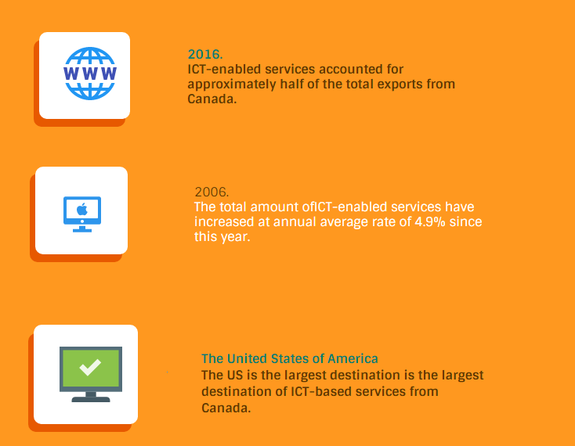
Canada is a technological hub, and that is the reason why ICT-enabled services accounted for approximately half of her total exports in 2016. The empirical evidence provided above shows that the total amount of ICT services that the country exports have significantly (Rostami n. p). The US remains the major destination for ICT services from Canada; therefore, Canadian technological experts have benefited the most from delivering their services in the country as compared to France and the United Kingdom (UK).
Digital Economy
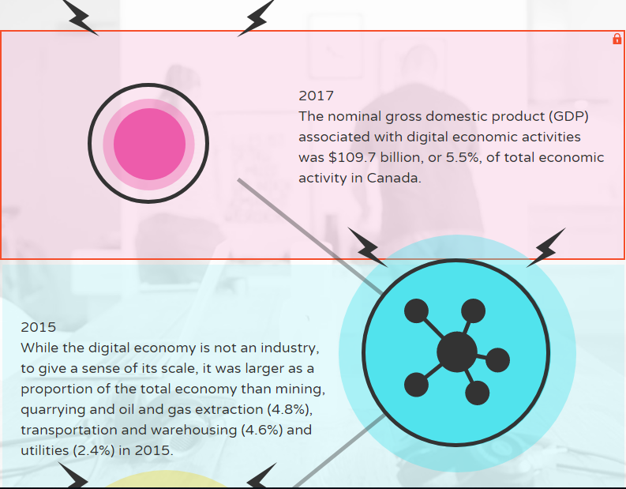

The Gross Domestic Product (GDP) related to digital economic contributed enormously to Canada’s total economic activity in 2017. Even though the digital economy is not an industry in the country, it constituted a large proportion of the economy than utilities, gas extraction, and warehousing industries (Statistics Canada n. p). In this regard, digital economic activities have grown significantly from 2010-2017; therefore, providing an incentive for international businesses that use the web for sales promotion and hosting.
Strategies for Global Positioning
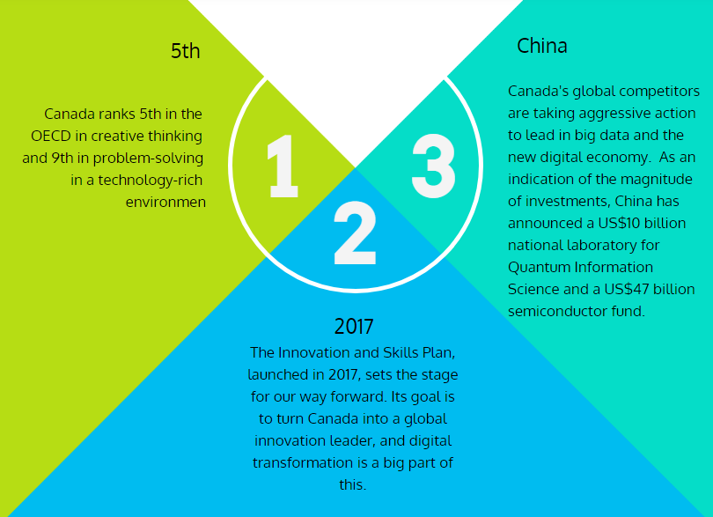

Canada's recognition as a creative-thinking and problem-solving nation by the OECD shows that she has innovation strengths that are crucial for digital transformation. In the face of huge spending by her competitors, the country launched the Innovation and Skills plan in 2017 to reap the benefits in the global digital market (Government of Canada n. p).
Knowledge Economy
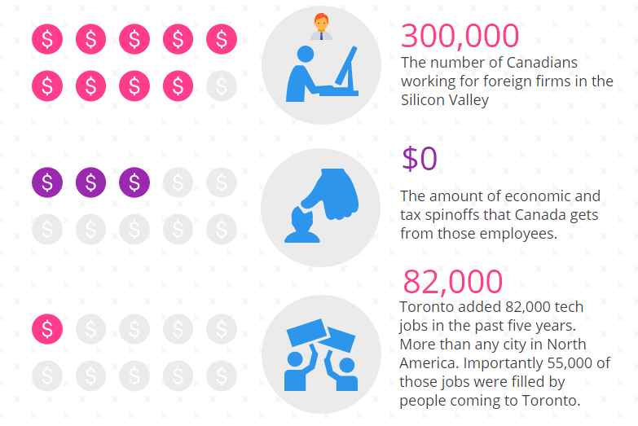
Most of Canadians that go to the US to take up digital jobs that foreign-based companies in Silicon Valley provided do not return home (Clark n. p). Consequently, the Canadian government accrues almost zero national revenue from this proportion of the knowledge economy. However, locals taking up jobs that Toronto provided shows that the government can harness the economic benefits of its educated population.
The Value of Labor
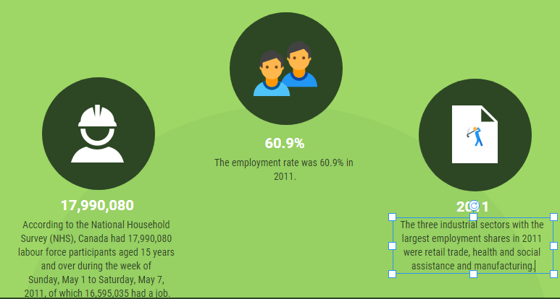
The statistical evidence provided above shows that most the active labor force is employed and the industries that provide the highest employment opportunities include retail trade, manufacturing, and health and social assistance (Statistics Canada n. p).

Works Cited
Clark, Ed. “How does Canada win the Knowledge Economy War?” The Globe and Mail, 2018.
https://www.theglobeandmail.com/opinion/article-how-does-canada-win-the-knowledge-economy-war/
Government of Canada. “Positioning Canada to lead in a Digital-and Data-driven economy:
Discussion Paper.” 2019
https://www.ic.gc.ca/eic/site/084.nsf/eng/00007.html
Rostami, Mitra. “Canada’s International Trade in Information and Communications
Technologies (ICT) and ICT-enabled Services.” Statistics Canada, 2018.
https://www150.statcan.gc.ca/n1/pub/13-605-x/2018001/article/54965-eng.htm
Statistics Canada. “Portrait of Canada’s Labor Force.” 2011.
https://www12.statcan.gc.ca/nhs-enm/2011/as-sa/99-012-x/99-012-x2011002-eng.cfm
Statistics Canada. “Measuring Digital Economic Activities in Canada, 2010 to 2017.” 2019
https://www150.statcan.gc.ca/n1/daily-quotidien/190503/dq190503a-eng.htm

